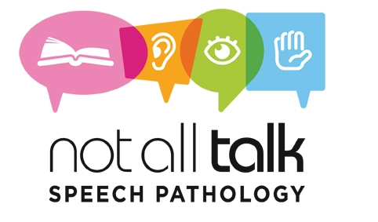
Consent to release information
I, _____________________________________ father/mother/guardian (please circle) of

________________________________________ (client’s name), born on

____________________________ (child’s date of birth) give permission for

Speech Pathologist_________________________ to contact the following professionals

named below, regarding information about my child.

School/Preschool: __________________________________________________________

Schoolcounsellor/Psychologist: _______________________________________________

Speech Pathologist: ________________________________________________________

Doctor: __________________________________________________________________

Other professional: _________________________________________________________

I would/would not (please circle) like copies of reports sent to those named above.

Signature:________________________________________________________________

Date:____________________________________________________________________

Contact number: ___________________________________________________________
Contact email: _____________________________________________________________
Please note: Consent is only valid for the duration of therapy and can be cancelled upon request at any time.

