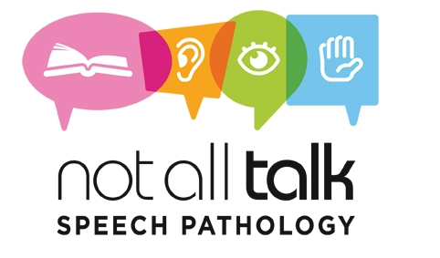

CONSENT FOR PHOTOGRAPHS/AUDIOVISUAL MATERIAL

I, _____________________________________ father/mother/guardian (please circle) of

________________________________________ (client’s name), born on

____________________________ (child’s date of birth) give permission for

Not All Talk Speech Pathology to obtain photographs/ audiovisual material for the purpose of: (please tick- a selection has been recommended, for your assistance).

€ Providing a service to my child

€ Recording a session

€ Promotional material

€ Training purposes

Details: All recordings to be provided to family within 24 hours of a session.
All recordings will be deleted from system once family have confirmed file was received.

Signed: .
Relationship to child: .

Please note: Consent is only valid for the duration of therapy and can be cancelled upon request at any time.

